GEORGEINNNEWSJANUARY2020
Looking back…..
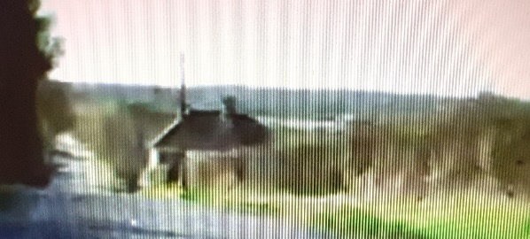
Running a pub these days is not easy. Many have had to close. There is a lot against us at The George Inn, being isolated in the middle of the countryside, and on a very fast road!

Despite this 2019 was a good year. We were delighted to welcome many of our near neighbours, people from the local area, from Kent more widely, visitors from other parts of the UK, and tourists from different countries including the USA and Australia as well as from Europe.
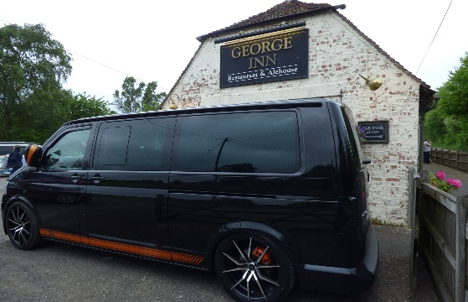
We had our first stopovers in the summer. Two very impressive campervans arrived and the occupants all enjoyed a meal in the restaurant and then a good night’s sleep before continuing with their travels.

We feel blessed to be able to share in the lives of so many different people, if only for a while, as they stop for a meal or a drink with us. We are also delighted if they share their experience on Trip Advisor or Facebook, saying they will return.
Delicious and good value….. with great hospitality from Mike the landlord. Other people ate while we were there and their meals looked equally appetising. There were a number of cars in the car park when we arrived but the pub was empty but this was soon resolved when a group of walkers arrived from a walk and nice to see they had all booked for lunch. We will return. Dave G on Trip Advisor (December 2019)

Our menus have continued to develop as we try to tempt customers with locally sourced food and also meet the changes that people are making in their diet. Our four bird and wild boar pies are always popular but equally customers ask for vegetarian, vegan and gluten free dishes as diets change.

Richard, our chef, is expert at devising interesting dishes such as:
- Farmhouse Onion: onion cases filled with diced onion, cheese, wild mushrooms and basil served with a cream and red wine sauce;
- Macaroni Pasta Loaf
Both dishes are for vegetarians.
- Wild Mushroom Risotto, a traditional risotto finished with cream or almond cream is a vegan dish.

Looking forward…….

Our live music nights continue with jazz every Thursday. A different band plays each week. We are privileged to be able to enjoy so much original talent in our local area, and for free! Sad to say, we lost one of their members in the last weeks of 2019. Ken played the banjo with Vocalion. He will be greatly missed by regular visitors to jazz at The George.

Geoff and Lorna organise a very different experience with an acoustic night on the third Wednesday of each month. This features a range of genres and includes vocal and instrumental music. Just turn up and join in or just sit back and enjoy!

Folk musicians play together on the first Sunday evening of the month and are very happy to share their talents with an audience.

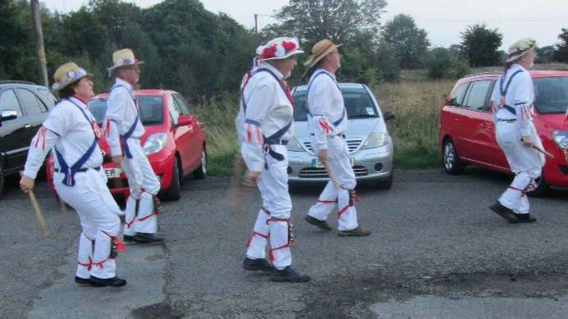
And finally, we hope to see the East Kent Morris men back at The George Inn.
East Kent Morris is a mixed side with a long history of dancing Cotswold style Morris – the ‘traditional’ kind with bells, sticks and handkerchiefs. They wear red, white and blue kit to celebrate Queen Elizabeth II’s coronation in 1953, the year they were founded.

They have the Invicta symbol on the back of their red waistcoats. Invicta is Kent’s rampant white horse, seen on village nameplates all over the county. They even have their own wooden horse called Invicta, who is allowed out occasionally; keep a tight grip on your small change if he looks hungry! But do come and support this great event at the end of the summer!
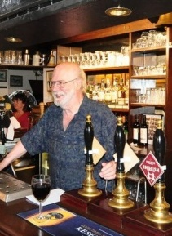
Our Supper Club meetings for 2020 will take place on the first Wednesday in the month.

We are planning to start the year off with a ‘winter warmer’ – a warming meal including Spicy Crab Cakes, Steak and Kidney Pudding and finishing off with Eve’s Pudding and a glass of warm mulled wine! At £22 per person, you can’t afford to miss this treat!

So, put Wednesday 5th February in your new 2020 diary! Everyone is welcome but you do need to BOOK YOUR PLACE!
Hope to see you again, soon! Michael

