GEORGEINN
NEWSFEB20
Hello again.
In the winter months and, often, right through to May or June, much of my time and attention is given to our well-known open fire. I try to keep it going night and day…..it keeps the building warm and provides a cheerful blaze to lift our spirits through the cold nights, rainy days and the inevitable storms!

Recently, I came across some information buried under my pile of paperwork! This was recorded during building alterations at the pub at some time in the past. It may be that someone still remembers this discovery. If so, do get in touch.
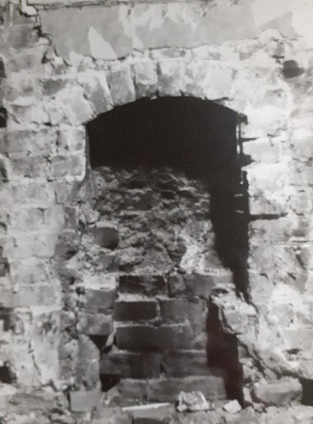
“The wall behind the servery at the George Inn covered a small ‘bird’s nest’ fireplace preserved under the plaster.
This is believed to be a baking oven”.

Unhappily, the fireplace was covered up again with plaster but several old coins were found nearby, dating back to George III.
The fact that none of the coins were of a higher denomination than a penny reminds me of how little beer cost in those days! Indeed most of the coins were half pennies and there was one farthing!
Our live music nights feature a different jazz band every Thursday night. Steamboat plays on the first Thursday of every month. This month Steamboat included Sarah on tenor sax, clarinet and vocals and Jimmy on drums. What a special night! Everyone there was bowled over with the quality of the jazz – a very special experience!

Our first Supper Club menu of 2020 was a ‘winter warmer’. As part of the three course meal, three huge Steak and Ale puddings were divided up between the eleven members. Conversation flowed as readily as the mulled wine! Do look at our March Supper Club Menu – can we tempt you to join us?
See you again, soon.
Michael
GEORGEINN
SUPPERCLUB

Date of Next Meeting:
Wednesday 4th March
Time:
7pm for 7.30pm
Price:
£23.50 per person
____________________
Everyone is welcome
but you do need to
BOOK YOUR PLACE
by
Wednesday 26th February
_____________________

THIS MONTH’S MENU
Root Vegetable Terrine
Fresh local vegetables
seasoned with herbs,
and pure-ed and layered
to make a colourful terrine

Salmon En Croute
Fresh salmon topped with mushroom and individually wrapped in puff pastry
Served with a lemon and dill sauce
New potatoes
and a selection of
locally grown, seasonal vegetables

Kentish Lent Tart
A light tart of ground rice,
eggs and raisons
flavoured with nutmeg and lemon
and served with Chantilly cream

All washed down
with white wine spritzer
Try our new menus Enjoy a good night out Meet new people Keep in touch with friends Catch up with the neighbours Enjoy the cosy warmth of our huge log fire
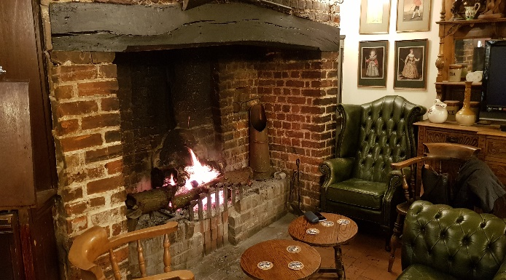

TO BOOK YOUR PLACE
Phone Michael: 01227709170
Or E-mail: landlord@thegeorgeonstonestreet.co.uk
and
Go to: www.thegeorgeonstonesreet.co.uk to subscribe to our Newsletter and keep up to date with our events.

